3. Implement Dynamic programming algorithm for computing the edit distance between strings s1 and s2. (Hint. Levenshtein Distance

Input:

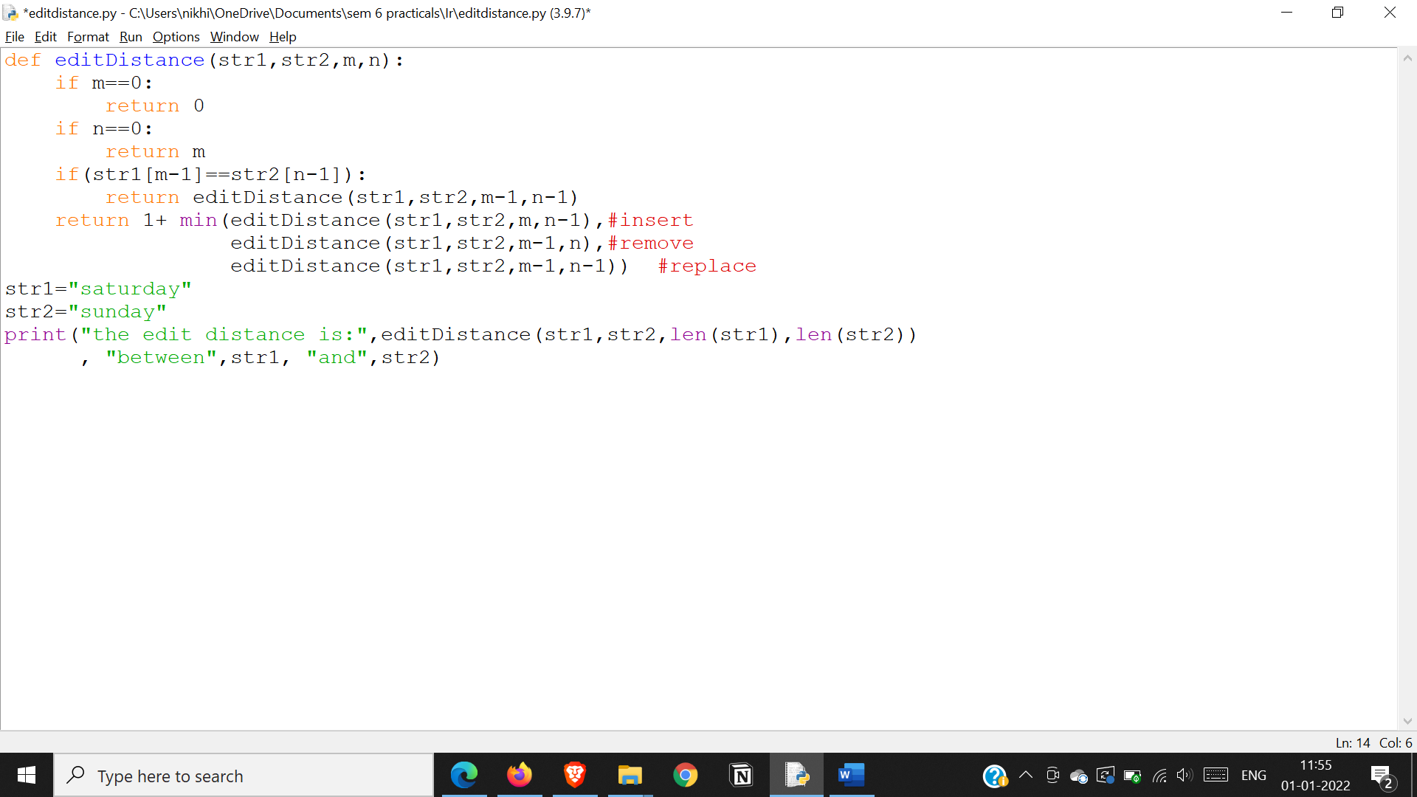

Output

